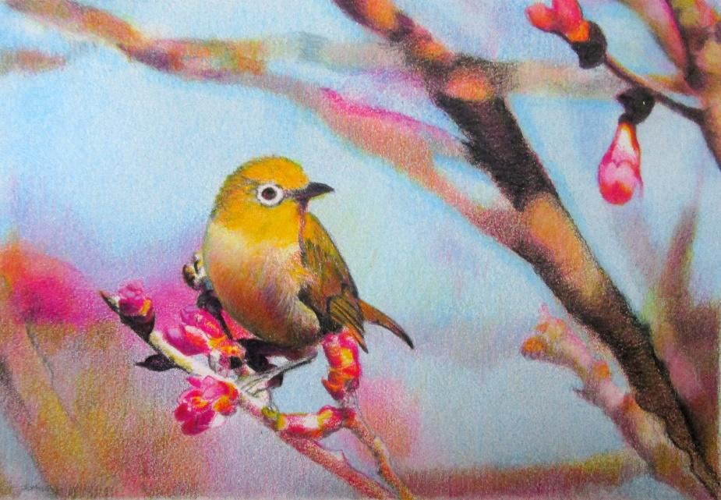
Colored Pencil by Andria Burchett

By using a small section of primary colors, you will become a master of manipulating color, value and intensity. Breaking down the thought process of creating color will train you to become more aware and confident in your color pencil choices. Once you return to your pencil set of full range colors, you will no longer be mystified by which color to choose.

Here’s what you’ll learn:
- How to create a unity in your overall work by limiting your palette
- How to build a wide range of colors by using just a few (great for travel!)
- How to determine which “next pencil” to use when returning back to your full set of colors

