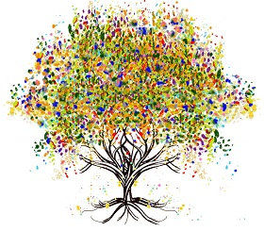

Beech Tree Studio

Drawn Together 2025

Update Information
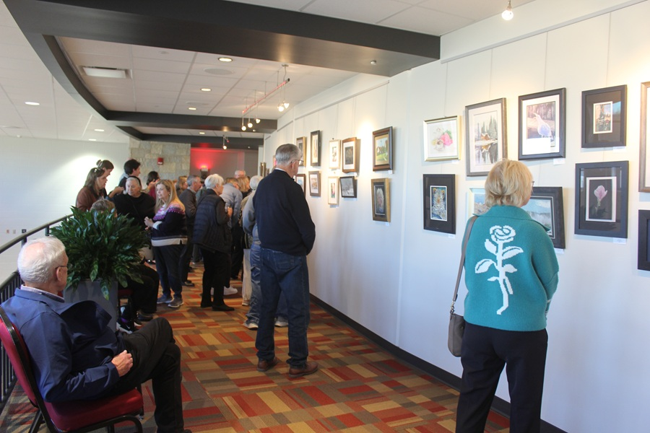
What a success!
Our Drawn Together 2025 Show includes over 100 pieces of colored pencil artistry by our Beech Tree Studio family of artists, and we are so excited about the venue this year at the Batavia Fine Arts Centre.
Thank you to all the artists who participated, making this an extraordinary fine art exhibit, and to the team of volunteers who physically make this show possible.

Here are a few things to know….
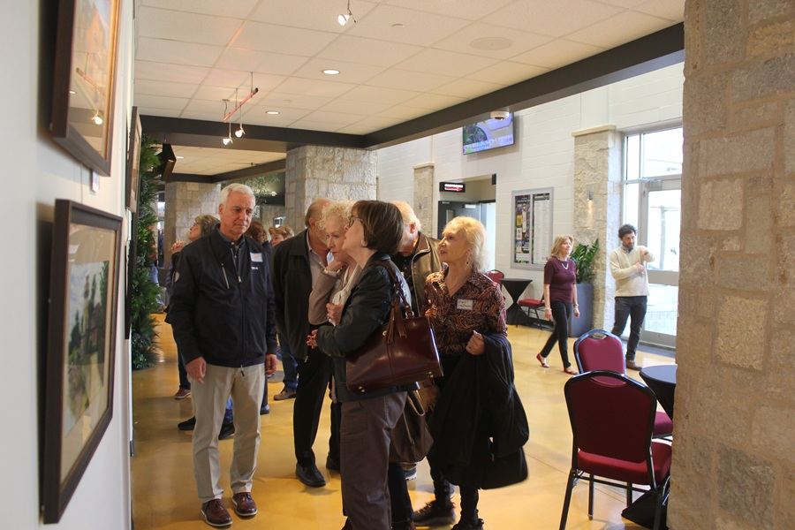

How to See the Show
If you weren’t able to attend the artists’ reception in November, or if you did and want to take another swing through, there will be an additional “viewing” on Wednesday, February 25th from 4:00- 6:00.

Did you know that you can also view the show online anytime you want?
Here’s the link.

Art Take-Down
Artists may collect their work on March 9 or 10, from 4:00- 6:00. If you are not available to pick up your artwork, please arrange for a friend or family member to do so.

Thanks again for your participation and support of the artists of Beech Tree Studio.

Warmly,
Andie

beechtreestudio.com

